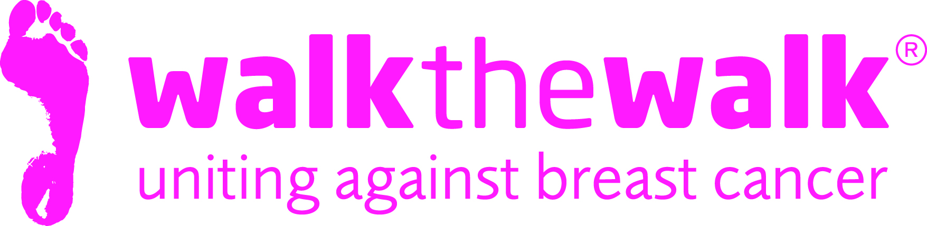

PHOTOCALL NOTICE
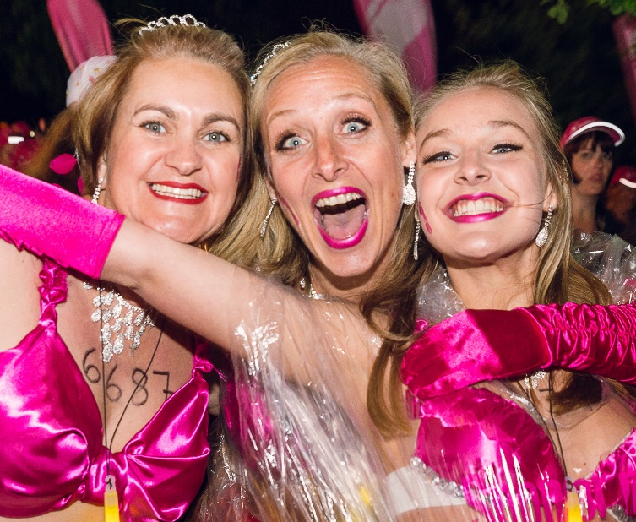
Salsa, Mambo, Calypso - The MoonWalk London’s Midnight Carnival!
Saturday 14th May

- What: The MoonWalk London 2016
- When: Saturday 14th May (8pm) to Sunday 15th May (1pm)
- Where: Walk the Walk’s huge pink palace on Clapham Common
- About: Grant-making breast cancer charity Walk the Walk is celebrating its 20th anniversary with a carnival- themed celebration. 15,000 women and men wearing brightly decorated bras will Power Walk a Half or Full Marathon through the streets of London at Midnight to raise money and awareness for breast cancer
Photo and interview opportunities include:
- Nina Barough CBE, Founder and Chief Executive of Walk the Walk Worldwide
- Harriet Thorpe, Actress and Walk the Walk Ambassador
- Sally Lindsay, Actress
- Lindsay Nicholson, Editor of Good Housekeeping
- Justine Roberts, Mumsnet Founder
- Mary Yeates (85) and Paul Freedman (91), accompanied by models from “Pearls and Pecs”
- The Tootsie Rollers, retro girl band
- Baroness Delyth Morgan, Jane Ellison MP, Seema Malhotra MP, Mike Freer MP, Ruth Cadbury MP
- OTHER CELEBRITIES TO BE ANNOUNCED

For media accreditation or photos, contact:
- Sally Orr at Walk the Walk. 07796 080 675 sally@walkthewalk.org
- Jennifer McAllister at Walk the Walk. 01483 741430 jennifermc@walkthewalk.org

Notes to editors:

Walk the Walk
- Nina Barough CBE, Founder and Chief Executive, set up and leads the grant-making breast cancer charity Walk the Walk.
- Walk the Walk is passionate about encouraging women and men to become fitter and healthier and take control of their own wellbeing.
- The charity is celebrating its 20 years of Walking the Walk. In 1996, Nina woke up with the idea of Power Walking the New York City Marathon in a bra to raise money for research into breast cancer.
- Nina was diagnosed with breast cancer herself shortly afterwards, which was the starting point for Walk the Walk and The MoonWalk.
- Walk the Walk has now raised over £108 million, which is granted to fund breast cancer research and to help improve the lives of people with cancer.
- Walk The Walk also organises the following events:- The MoonWalk Scotland (11th June 2016), The MoonWalk Iceland (18th June 2016) and The Arctic Marathon – a 26.2 mile backcountry skiing challenge in the far north of Lapland.
- Additionally, Walk the Walk takes walkers to events including the Inca Trail Peru, Berlin Marathon, New York Marathon, Paris Marathon, Dublin Marathon and the Nijmegen Marches.
- Since it launched, Walk the Walk has made grants for research to Breakthrough Breast Cancer and Breast Cancer Campaign (for its ground-breaking Breast Cancer Tissue Bank). The two charities recently merged to form Breast Cancer Now. Funding from Walk the Walk has made possible Breast Cancer Now’s Legacy Study for Secondary Breast Cancer.
- Walk the Walk is also committed to providing funding to hospitals across the UK to purchase Scalp Cooling systems, special machines which are helping many people undergoing chemotherapy to retain their hair.
- Grants from Walk the Walk have also been made to the following charities, to help improve the lives of people with cancer: Maggie’s Cancer Care Centres, Penny Brohn Cancer Care, Tenovus, The Haven, The Christie Hospital, Helen Rollason Cancer Charity
- For more information, and to sign up for all Walk the Walk’s challenges, as a Walker or a Volunteer, go to www.walkthewalk.org

