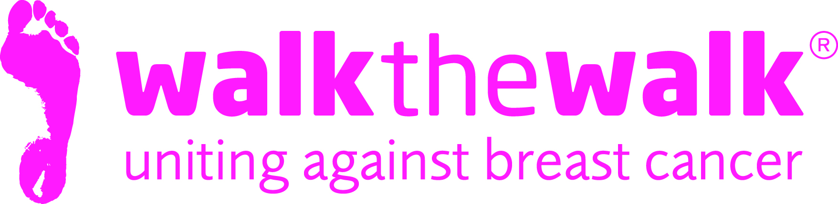
PRESS RELEASE
Sunday 15th May 2016

Hotting up the streets of the capital with The MoonWalk London’s Midnight Carnival!

It was a little chillier than Rio, but 15,000 walkers wearing decorated bras brought a little heat to the capital during Saturday night’s carnival themed MoonWalk London.

Organised by breast cancer charity Walk the Walk, this iconic night-time challenge brings women and men together from all over the UK and the world as they unite to raise money and awareness for breast cancer. The charity’s Founder and Chief Executive Nina Barough announced that over £3.5 million had been raised before one step had even been taken.

Celebrating 20 years of Walking the Walk, the event was supported by Jennifer Saunders and her friend, the charity’s Ambassador, Harriet Thorpe. Harriet said “This is the biggest year ever, we’ve got our best Jen’s Big Tits team ever and I’m incredibly moved to walk this year in memory of Victoria Wood, with whom I did my first MoonWalk 13 years ago”
Walkers wearing wonderful over the top carnival creations, featuring feathers, sequins and crazy headdresses power walked past many moonlit London landmarks including the Houses Of Parliament.

One walker who swapped Parliament for the pavements on Saturday was MP for Battersea and Public Health Minister with responsibility for cancer, Jane Ellison. She said: “Even a bit of a chill in the air couldn’t dampen the carnival atmosphere on one of the most remarkable nights of fundraising any of us have ever had the pleasure of taking part in. For me, the knowledge that the money raised is making such a big difference in the fight against cancer makes the occasion all the more moving”
Entries for The MoonWalk London 2017 open on Thursday 19th May at www.walkthewalkorg

ENDS

For more information, or to arrange photos, contact:
- Sally Orr at Walk the Walk Worldwide 07796 080675 sally@walkthewalk.org

Notes to editors:

Walk the Walk
- Nina Barough CBE, Founder and Chief Executive, set up and leads the grant-making breast cancer charity Walk the Walk.
- Walk the Walk is passionate about encouraging women and men to become fitter and healthier and take control of their own wellbeing.
- The charity is celebrating its 20 years of Walking the Walk. In 1996, Nina woke up with the idea of Power Walking the New York City Marathon in a bra to raise money for research into breast cancer.
- Nina was diagnosed with breast cancer herself shortly afterwards, which was the starting point for Walk the Walk and The MoonWalk.
- Walk the Walk has now raised over £108 million, which is granted to fund breast cancer research and to help improve the lives of people with cancer.
- Walk The Walk also organises the following events:- The MoonWalk Scotland (11th June 2016), The MoonWalk Iceland (18th June 2016) and The Arctic Marathon – a 26.2 mile backcountry skiing challenge in the far north of Lapland.
- Additionally, Walk the Walk takes walkers to events including the Inca Trail Peru, Berlin Marathon, New York Marathon, Paris Marathon, Dublin Marathon and the Nijmegen Marches.
- Since it launched, Walk the Walk has made grants for research to Breakthrough Breast Cancer and Breast Cancer Campaign (for its ground-breaking Breast Cancer Tissue Bank). The two charities recently merged to form Breast Cancer Now. Funding from Walk the Walk has made possible Breast Cancer Now’s Legacy Study for Secondary Breast Cancer.
- Walk the Walk is also committed to providing funding to hospitals across the UK to purchase Scalp Cooling systems, special machines which are helping many people undergoing chemotherapy to retain their hair.
- Grants from Walk the Walk have also been made to the following charities, to help improve the lives of people with cancer: Maggie’s Cancer Care Centres, Penny Brohn Cancer Care, Tenovus, The Haven, The Christie Hospital, Helen Rollason Cancer Charity
- For more information, and to sign up for all Walk the Walk’s challenges, as a Walker or a Volunteer, go to www.walkthewalk.org

