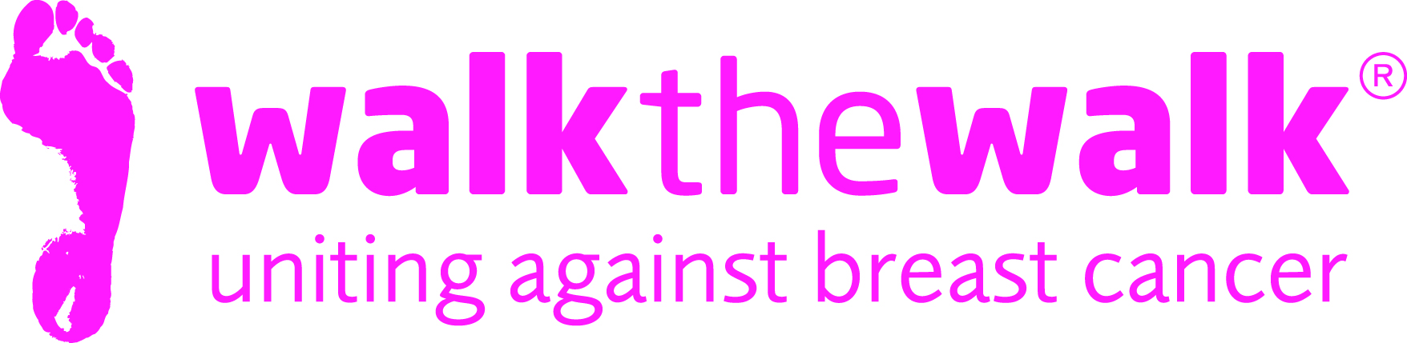

PHOTOCALL NOTICE
Swing your Tartan - at The MoonWalk Scotland 2016!
Saturday 11th June
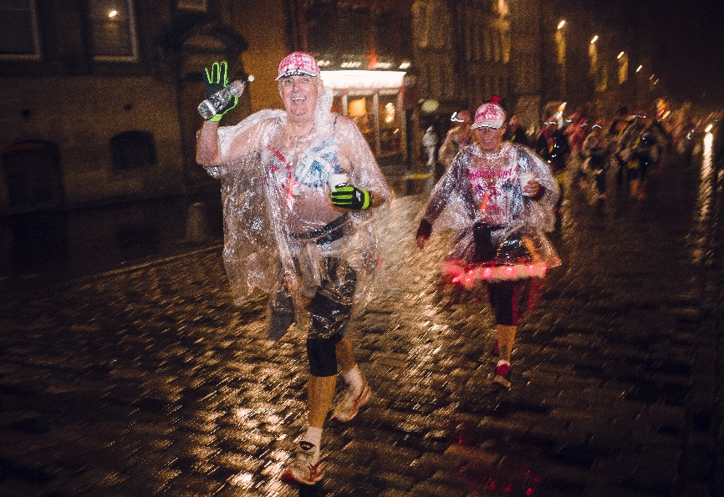

- What: The MoonWalk Scotland 2016
- When: Saturday 11th June (8.30 pm) to Sunday 12th June (2pm)
- Where: Breast cancer charity Walk the Walk’s huge tent in Holyrood Park, Edinburgh
- About: Thousands of women and men wearing brightly decorated bras will Power Walk a quarter, half, full or double marathon through the streets of Edinburgh at Midnight to raise money and awareness for breast cancer.
Photo and interview opportunities include:
- Bras. Thousands of decorated bras to fit with this year’s theme, “Swing your Tartan”
- Nina Barough CBE, Founder and Chief Executive of Walk the Walk Worldwide
- Arlene Stuart. Presenter on Radio Forth and hosting The MoonWalk Scotland
- Mark Martin. Presenter on Radio Forth and hosting The MoonWalk Scotland
- Bahookie. Scottish rock Ceilidh band, playing for walkers before they start their challenges

For media accreditation or photos, contact:
- Sally Orr at Walk the Walk. 07796 080 675 sally@walkthewalk.org
- Jennifer McAllister at Walk the Walk. 01483 741430 jennifermc@walkthewalk.org

Notes to editors:

The MoonWalk Scotland 2016
- Saturday 11th June, Holyrood Park, Edinburgh
- Thousands of women, men and children will walk through the streets of Edinburgh at Midnight, with those aged 13 and over wearing Walk the Walk’s trademark brightly decorated bras.
- Four walking distances are available: New Moon (6.55 miles – minimum age 10 years old); Half Moon (13.1 miles) and Full Moon (26.2 miles) – both minimum age 13 years old; Over The Moon (52.4 miles – minimum age 18 years old)
- Entries for Walkers are now closed. For more information about The MoonWalk Scotland and to register as a Volunteer, go to www.walkthewalk.org
- The MoonWalk Scotland has raised over £19 million to date, with most of the money raised staying in Scotland to help improve the lives of people with cancer.
- Walk the Walk has made grants in Scotland to Maggie’s Cancer Care Centres in Glasgow and Airdrie and is the principle funder of Maggie’s Forth Valley, which is due to open in Larbert later this year.
- Walk the Walk has also funded the renovation of Ward 6, a new theatre and renovation of the Mammography Unit at the Breast Cancer Institute at Edinburgh’s Western General Hospital
- Walk the Walk is committed to providing funding to hospitals across Scotland and the UK to purchase Scalp Cooling systems, special machines which are helping many people undergoing chemotherapy to retain their hair. Walk the Walk has funded 54 Scalp Coolers in 24 Scottish hospitals

Walk the Walk
- Nina Barough CBE, Founder and Chief Executive, set up and leads the grant-making breast cancer charity Walk the Walk.
- Walk the Walk is passionate about encouraging women and men to become fitter and healthier and take control of their own wellbeing.
- The charity is celebrating its 20 years of Walking the Walk. In 1996, Nina woke up with the idea of Power Walking the New York City Marathon in a bra to raise money for research into breast cancer.
- Nina was diagnosed with breast cancer herself shortly afterwards, which was the starting point for Walk the Walk and The MoonWalk.
- Walk The Walk also organises the following events:- The MoonWalk Iceland (18th June 2016), The Arctic Marathon – a 26.2 mile backcountry skiing challenge in the far north of Lapland and The MoonWalk London (13th May 2017)
- Additionally, Walk the Walk takes walkers to events including the Inca Trail Peru, Berlin Marathon, New York Marathon, Paris Marathon, Dublin Marathon and the Nijmegen Marches.

