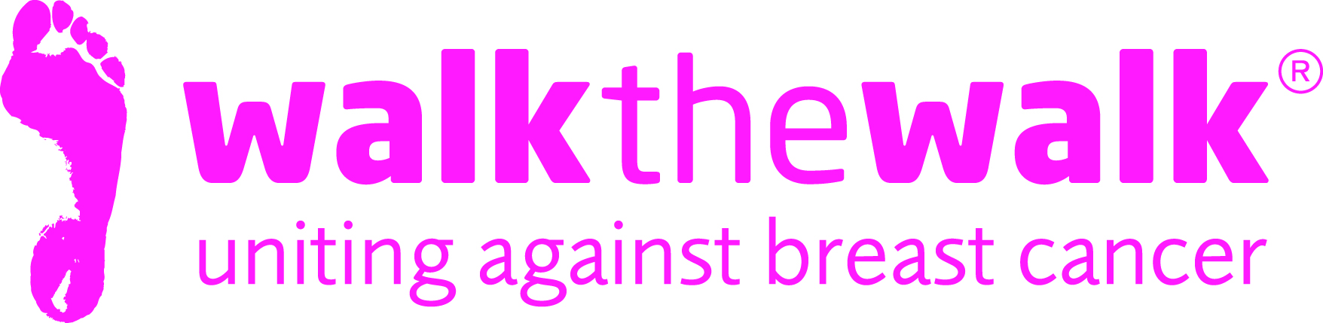

PHOTOCALL NOTICE
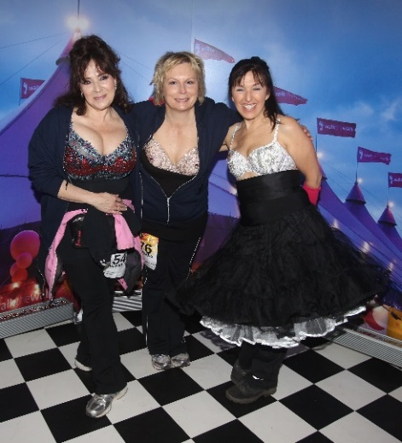
Celebrities show their bras for Breast Cancer Awareness Month!
Tuesday 4th October

- What: Bra Exhibition, organised by breast cancer charity Walk the Walk, to celebrate 20 years of
Walking the Walk.
- When: Tuesday 4th October, 6pm – 8pm
- Where: The Good Housekeeping Institute, 21-25 St Anne’s Court, London W1F 0BJ
- About: Celebrities including Little Mix, Alan Carr and Lorraine Kelly are supporting MoonWalk
organisers Walk the Walk during Breast Cancer Awareness Month, by contributing to a
stunning collection of one-of-a-kind bras, decorated by famous designers. It is thanks to
walkers wearing the decorated bra - Walk the Walk’s trademark – that the charity has
raised £113 million through The MoonWalk London and other events. Over the last 20
years, bras have been decorated by a wonderful variety of celebrities, artists,
politicians, authors, designers and musicians.
Photo opportunities include:
- Ab Fab bra, signed by Harriet Thorpe and Jennifer Saunders, created by Victoria Grant
- Little Mix bra, created by Jane Bowler
- Alan Carr bra, created by Julien Macdonald
- Zandra Rhodes bra
- Lorraine Kelly bra, created by Barbour

Quotes are available for all bras from celebrities and designers

For media accreditation, more information, and Free to Use photos, contact:
- Sally Orr at Walk the Walk. 07796 080 675 sally@walkthewalk.org
- Claire Duncan at Walk the Walk. 07834 530307
Notes to Editors

The MoonWalk London 2017
- Saturday 13th May 2017, Clapham Common
- 2017 will be the 20th MoonWalk London.
- Two walking challenges are available: Half Moon (13.1 + 2 miles) or Full Moon (26.2 miles)
- This year’s theme is “The Roaring Twenties”
- All participants must be aged 13 and over to take part
- The cost of entering the Half Moon and Full Moon is £48.50
- Walkers are asked to raise a minimum of £100 in sponsorship
- Entries are open at www.walkthewalk.org

Walk the Walk
- Nina Barough CBE, Founder and Chief Executive, set up and leads the grant-making breast cancer charity Walk the Walk.
- Walk the Walk is passionate about encouraging women and men to become fitter and healthier and take control of their own wellbeing.
- In 1996, Nina woke up with the idea of Power Walking the New York City Marathon in a bra to raise money for research into breast cancer.
- Nina was diagnosed with breast cancer herself shortly afterwards, which was the starting point for Walk the Walk and the first MoonWalk London in 1998.
- Walk the Walk has now raised £113 million, which is granted to fund breast cancer research and to help improve the lives of people with cancer.
- Walk The Walk also organises the following events:- The MoonWalk Scotland (10th June 2017), The MoonWalk Iceland (17th June 2017) and The Arctic Marathon – a 26.2 mile backcountry skiing challenge in the far north of Lapland.
- Additionally, Walk the Walk takes walkers to events including the Inca Trail Peru, Berlin Marathon, New York Marathon, Paris Marathon, Dublin Marathon and the Nijmegen Marches.
- Since it launched, Walk the Walk has made grants for research to Breast Cancer Now for its Generations Study, the Legacy Study into Secondary Breast Cancer and the UK’s first ever Breast Cancer Tissue Bank.
- Walk the Walk has also funded a pilot study by charity Medical Detection Dogs to investigate if dogs that can already smell cancers, can distinguish breast cancer from other types of cancer.
- Walk the Walk is also committed to providing funding to hospitals across the UK to purchase Scalp Cooling systems, special machines which are helping many people undergoing chemotherapy to retain their hair.
- Grants from Walk the Walk have also been made to the following charities, to help improve the lives of people with cancer: Maggie’s Cancer Care Centres, Penny Brohn UK, Tenovus, The Haven, The Christie Hospital, Helen Rollason Cancer Charity
- For more information, and to sign up for all Walk the Walk’s challenges, as a Walker or a Volunteer, go to www.walkthewalk.org

