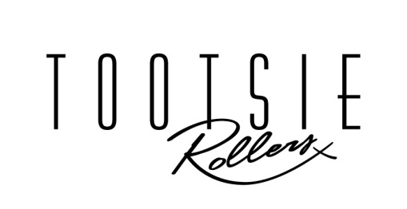
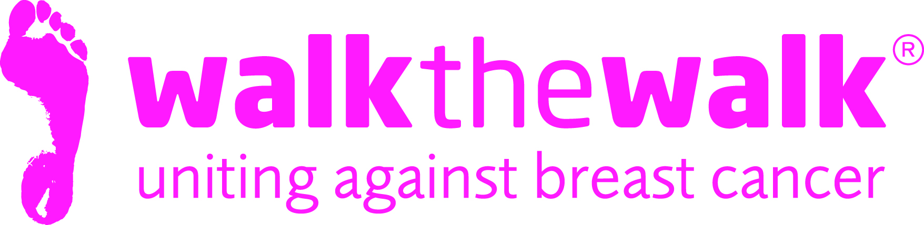
PRESS RELEASE

Tootsie Rollers launch “Walk the Walk” song for breast cancer!

International retro girl band, The Tootsie Rollers stopped the traffic in London’s Oxford Circus during Tuesday morning’s rush hour, as they launched a song written and recorded to support Breast Cancer Awareness Month. All proceeds of the single will be donated to breast cancer charity, Walk the Walk, organisers of the famous MoonWalks in London, Scotland and Iceland, who are celebrating 20 years of fundraising.

This incredibly catchy and very special song, simply titled “Walk the Walk” is inspired by The MoonWalk and can be downloaded from iTunes. The Tootsie Rollers fuse old-school classics with contemporary hits. They have taken their unique sound all over the world, and performed at a variety of venues from Royal Palaces to Music Festivals.

Nina Barough CBE, Founder and Chief Executive of Walk the Walk said “ We are so lucky that The Tootsie Rollers are such wonderful supporters of Walk the Walk and The MoonWalk, and I am incredibly touched by this amazing tribute! Not only is it a great song to walk to, but if everybody does their bit and downloads the song, it is a tremendous way to raise money and awareness for breast cancer”.
The Tootsie Rollers said "We are incredibly honoured to be releasing this track to help raise awareness and funds for such an important charity. All the proceeds from the song are going straight to the charity as it is one very close to our hearts. We hope the song may also inspire people to join the walk!"
As “Walk the Walk” was performed to startled onlookers in Oxford Circus, entries opened for The MoonWalk London 2016. On Saturday 14th May, thousands of women and men will once again walk through the streets of London from Clapham Common at Midnight, wearing the breast cancer charity’s trademark brightly decorated bras. Walkers will be uniting to save lives, as they raise awareness and millions of pounds for breast cancer causes.

Notes to editors:

For more details, spokespeople, case studies and photography, contact:-
- Sally Orr at Walk The Walk 07796 080675 sally@walkthewalk.org
- Jennifer McAllister at Walk the Walk 01483 741430 jennifermc@walkthewalk.org
- Georgia Segal, The Tootsie Rollers 07976 500 383 georgia@tcbgroup.co.uk

Tootsie Rollers
- “Walk the Walk” can be downloaded from iTunes at itunes.apple.com/gb/album/id1007631130
The MoonWalk London 2016

- Saturday 14th May 2016, Clapham Common
- Two walking challenges are available: Half Moon (13.1 + 2 miles) or Full Moon (26.2 miles)
- This year’s theme is “Carnival”
- All participants must be aged 13 and over to take part.
- The cost of entering the Half Moon and Full Moon is £47.50
- Walkers are asked to raise a minimum of £100 in sponsorship.
- Entries opened at 9am on Tuesday 20th October at www.walkthewalk.org
Walk the Walk
- Nina Barough CBE, Founder and Chief Executive, set up and leads the grant-making, health charity Walk the Walk.
- Walk the Walk is passionate about encouraging women and men to become fitter and healthier and take control of their own wellbeing.
- Walk The Walk also organises the following Power Walking events:- The MoonWalk Scotland (11th June 2016), The MoonWalk Iceland (18th June 2016)
- Walk the Walk is also the organiser of The Arctic Marathon – a 26.2 mile backcountry skiing challenge in the far north of Lapland.
- Additionally, Walk the Walk takes walkers to events including the Inca Trail Peru, Berlin Marathon, Paris Marathon, New York Marathon and the Nijmegen Marches.
- Since it launched, Walk the Walk has made grants for research to Breakthrough Breast Cancer and Breast Cancer Campaign (for its ground-breaking Breast Cancer Tissue Bank)
- Breast Cancer Campaign and Breakthrough Breast Cancer recently merged to form Breast Cancer Now. Funding from Walk the Walk has made possible Breast Cancer Now’s Legacy Study for Secondary Breast Cancer.
- A grant has also been made for research to the Medical Detection Dogs Charity.
- Walk the Walk is also committed to providing funding to hospitals across the UK to purchase Scalp Cooling systems, special machines which are helping many people undergoing chemotherapy to retain their hair.
- Grants from Walk the Walk have also been made to the following charities, to help improve the lives of people with cancer: Maggie’s Cancer Care Centres, Penny Brohn Cancer Care, Tenovus, The Haven, The Christie Hospital, and the Helen Rollason Cancer Charity
- For more information, and to sign up for all Walk the Walk’s challenges, as a Walker or a Volunteer, go to www.walkthewalk.org

