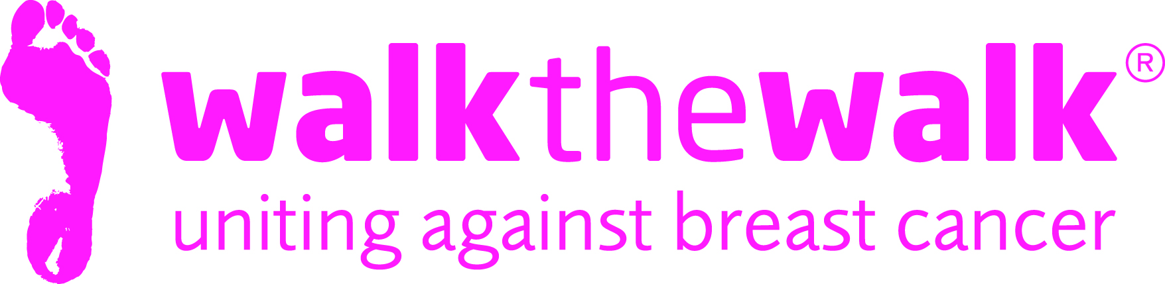
PRESS RELEASE
Salsa...Mambo...Calypso...Move your feet to the beat
and get ready for the The MoonWalk night time Carnival!
Breast cancer charity Walk the Walk is celebrating 20 years of Walking the Walk at the 2016 MoonWalk London. With its carnival theme, this iconic night time challenge will see thousands upon thousands of women and men walking through the streets of the capital at midnight on Saturday 14th May , wearing the charity’s trademark brightly decorated bras. This annual event has become a much loved night in the capital’s calendar and there’s no limit to how wild and wonderful the bras will be or how much money will be raised!
Entries for The MoonWalk London open at 9am on Tuesday 20th October, with Walkers having the choice of two challenges - either a Half Moon (13.1 + 2 miles) or Full Moon (26.2 miles).
In celebration, International retro girl band The Tootsie Rollers have written and recorded a song supporting Breast Cancer Awareness Month and Walk the Walk. All proceeds of the single are to be donated to the charity.
The song “Walk the Walk” is inspired by The MoonWalk . Download it today from iTunes itunes.apple.com/gb/album/id1007631130 and help make a difference to the fight against breast cancer.

Over the past 20 years, Walk the Walk has not only been dedicated to raising awareness and millions of pounds for breast cancer causes, but also passionate about encouraging women and men of all ages to set their own goal and to take more responsibility for their own well-being.
Nina Barough CBE, Chief Executive and Founder of Walk the Walk said: “It feels like only yesterday that the small group of just 13 women Walked the Walk for the first time in New York. It was only meant to be a one off fundraising event, so to be celebrating 20 years of the charity and raising over £104 million is somewhat mind boggling, but wonderful!
If people are looking for a really positive and very tangible way to make a difference during Breast Cancer Awareness Month, there is no better exchange than signing up for The MoonWalk, not only will they be raising money and awareness but you can become healthier and fitter at the same time, which as we now know, is a fundamental part of cancer prevention. It is a very empowering night to share with friends, family, and colleagues, have a lot of fun and help raise £6 million for vital breast cancer causes, with everybody’s help, Walking the Walk can save lives.”

ENDS

Notes to editors:
For more details, spokespeople, case studies and photography, contact:-
- Sally Orr at Walk The Walk 07796 080675 sally@walkthewalk.org
- Jennifer McAllister at Walk the Walk 01483 741430 jennifermc@walkthewalk.org
The MoonWalk London 2016

- Saturday 14th May 2016, Clapham Common
- Two walking challenges are available: Half Moon (13.1 + 2 miles) or Full Moon (26.2 miles)
- This year’s theme is “Carnival”
- All participants must be aged 13 and over to take part.
- The cost of entering the Half Moon and Full Moon is £47.50
- Walkers are asked to raise a minimum of £100 in sponsorship.
- Entries open at 9am on Tuesday 20th October at www.walkthewalk.org
Walk the Walk
- Nina Barough CBE, Founder and Chief Executive, set up and leads the grant-making, health charity Walk the Walk.
- Walk the Walk is passionate about encouraging women and men to become fitter and healthier and take control of their own wellbeing.
- Walk The Walk also organises the following Power Walking events:- The MoonWalk Scotland (11th June 2016), The MoonWalk Iceland (18th June 2016)
- Walk the Walk is also the organiser of The Arctic Marathon – a 26.2 mile backcountry skiing challenge in the far north of Lapland.
- Additionally, Walk the Walk takes walkers to events including the Inca Trail Peru, Berlin Marathon, Paris Marathon, New York Marathon and the Nijmegen Marches.
- Since it launched, Walk the Walk has made grants for research to Breakthrough Breast Cancer and Breast Cancer Campaign (for its ground-breaking Breast Cancer Tissue Bank)
- Breast Cancer Campaign and Breakthrough Breast Cancer recently merged to form Breast Cancer Now. Funding from Walk the Walk has made possible Breast Cancer Now’s Legacy Study for Secondary Breast Cancer.
- A grant has also been made for research to the Medical Detection Dogs Charity.
- Walk the Walk is also committed to providing funding to hospitals across the UK to purchase Scalp Cooling systems, special machines which are helping many people undergoing chemotherapy to retain their hair.
- Grants from Walk the Walk have also been made to the following charities, to help improve the lives of people with cancer: Maggie’s Cancer Care Centres, Penny Brohn Cancer Care, Tenovus, The Haven, The Christie Hospital, and the Helen Rollason Cancer Charity
- For more information, and to sign up for all Walk the Walk’s challenges, as a Walker or a Volunteer, go to www.walkthewalk.org

